Fibula flap

Flap Territory
This includes a segment of the fibular bone with or without the overlying skin island on the peroneal/ lateral aspect of the calf.

Vascular Territory
The peroneal artery and vein lies on the medial surface of the fibula, posterior to the interosseus membrane, making dissection relatively more difficult. At the bifurcation (anterior tibial and peroneal arteries), the vessels start posterior to and at some distance away from the bone before moving diagonally downwards to gain a position close to the bone.
There are some important points related to the vascularity of the leg and its variants
- Peronea arteria magna – a dominant peroneal artery with reciprocally small tibial vessels. This condition may be ipsilateral ie other leg may be satisfactory. It is rather rare.
- Low bifurcation – the pedicle would be short (and vein grafts may be necessary).
- Skin island may be supplied by perforators from posterior tibial system traversing the soleus, and thus separate from the peroneal artery system. It is a fallacy from the pre-perforator flap era that including a cuff of soleus/ FHL will improve the reliability of the skin island. Although it requires more dissection, tracing the perforators to the pedicle will optimize reliability; including unnecessary muscle has adverse implications – particularly reducing the maximum tolerable ischaemic time.

Flap Harvest
Preoperatively, if the pedal pulses (DP and PT) are palpable and strong then this is usually sufficient as a screening test. In selected patients – elderly, arteriopaths and post traumatic cases – an angiogram may be useful.
- Bend the knee to a 40-60 degree angle and mark the top and bottom of the fibula bone. It is conventional to leave some bone at both ends to preserve the common peroneal nerve (~4cm) and the ankle joint (6cm) respectively. Mark the posterior edge of the fibula which is the axis of the skin island.
- Mark an elliptical skin island centred on the axis along the posterior edge of the fibula (Fig 1) and at the junction of the middle and lower thirds of the fibula.

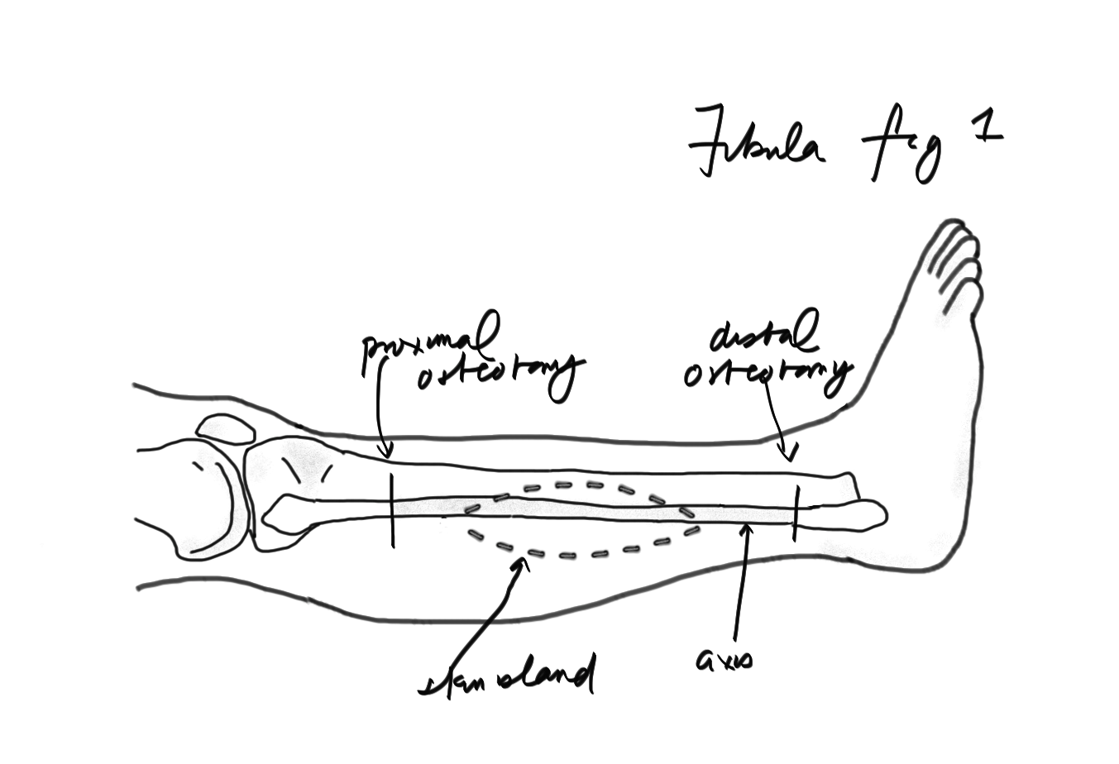

- Incise the anterior skin edge down through the fascia to the muscle – (usually the peroneals) and elevate the flap subfascially from anterior to posterior until you reach the posterior lateral intermuscular septum that is posterior to the peroneal muscles. You should be able to see the skin perforators.
  - Some suggest incising up to fascia and elevating for a distance suprafascially (Fig 2) - this protects the sural nerve and short saphenous vein posteriorly as well as the peroneal tendons anteriorly by not exposing them.

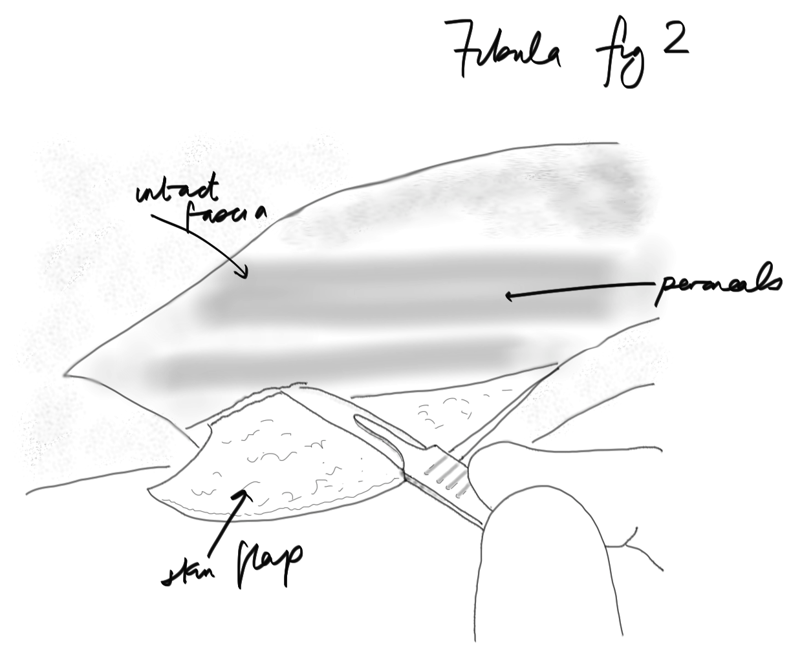

- Adjust your posterior incision if necessary and incise down to muscle (gastrocnemius/ soleus). Now elevate this posterior flap (sub)fascially in an anterior direction to meet the same septum and the perforators seen before. Perforators that run through the posterior muscles are more likely to arise from a system separate from the peroneal system and will not reliably supply the skin island. The muscles can be separated from the septum with gentle blunt dissection.
- Dissect the peroneal muscles away from the lateral surface of the fibula in an anterior direction (Fig 3) leaving a thin layer of muscle to ensure that the periosteum remains intact. When you reach the anterior edge of the fibula, incise the membrane you find there (anterior intermuscular septum) all the way down to the ankle. You can also divide the muscles (EHL and EDL) and interosseus membrane (IOM) at this point if you are able to see them.
- Cut the distal fibula at your selected level; after you do so note the proximity of the peroneal vessels and ligate/ divide them.
  - If you have identified the common peroneal nerve, you can also cut the proximal fibula at this time to facilitate mobilization of the bone.

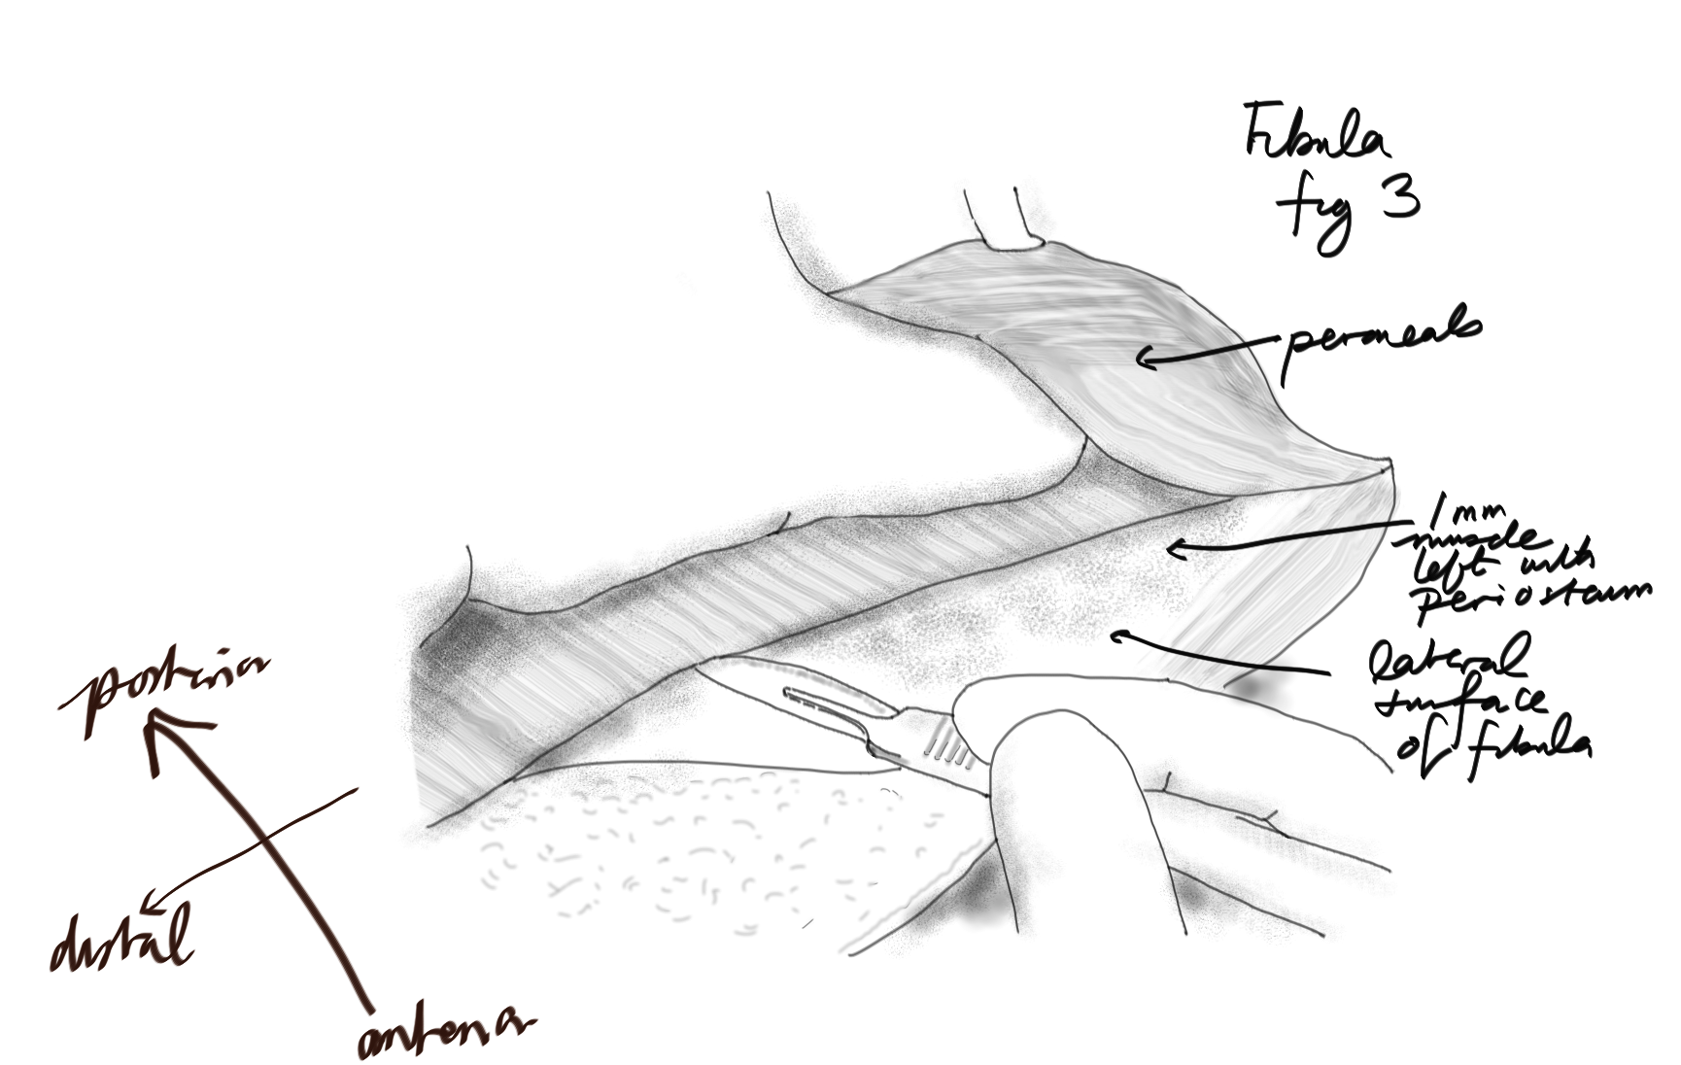

- Return to the posterior aspect of the fibula and divide the muscle attachments here (FHL and PT) (Fig 4). The peroneal vessels will be seen under this muscle layer. If you haven’t already divided the IOM then return to the anterior fibula and divide it. Fig 5.
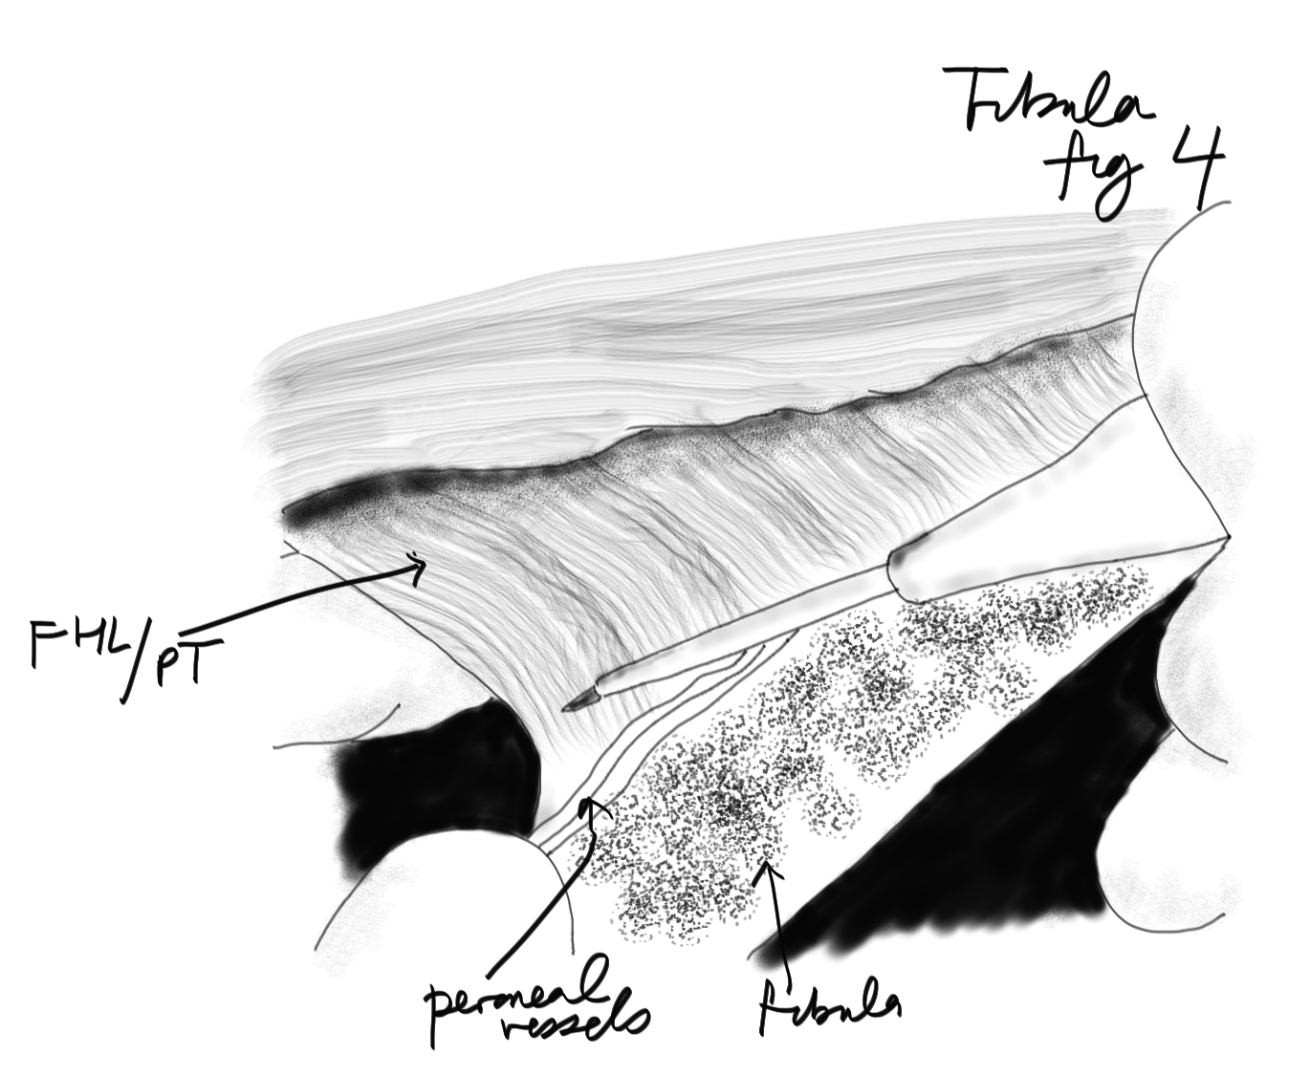

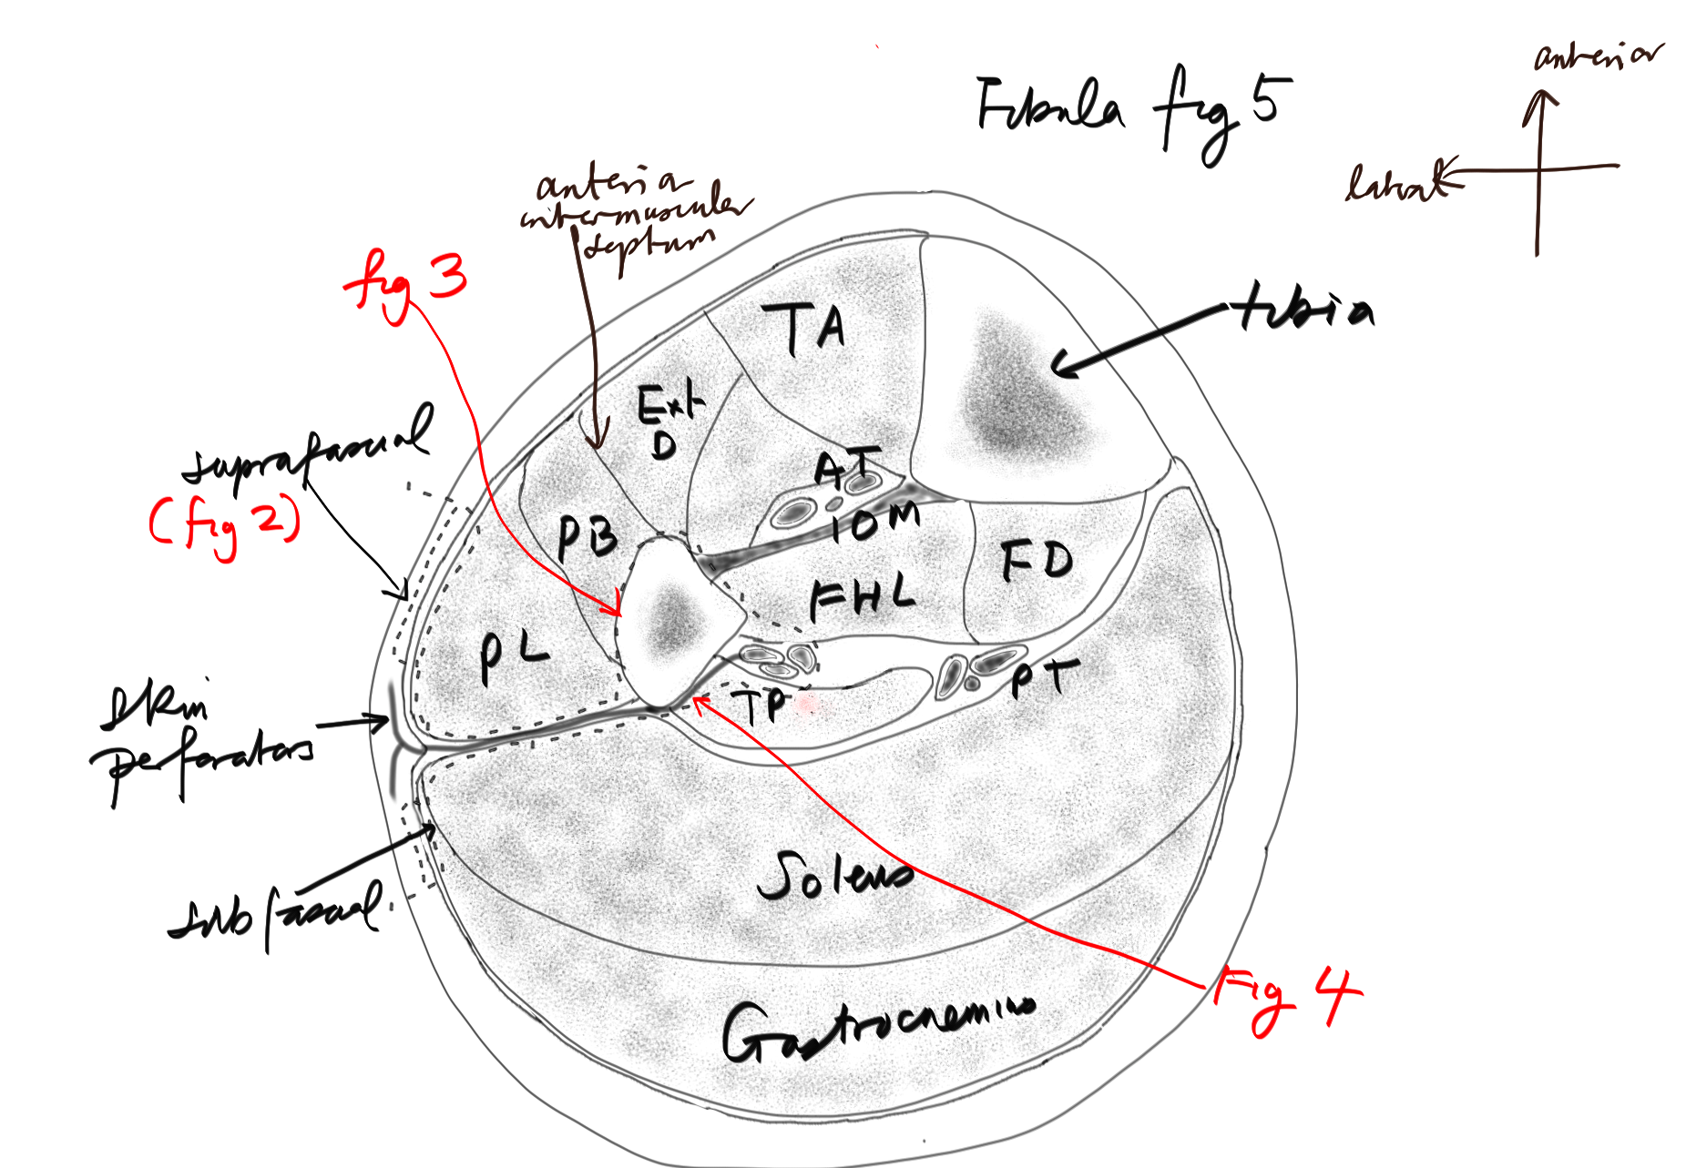

- Divide the proximal fibula if not already done so (taking an extra segment can help to improve access to the proximal peroneal vessels) and trace the vessels to the bifurcation.

References
Taylor GI et al. The free vascularized bone graft: a clinical extension of microvascular techniques. Plast Reconstr Surg 1975;55:533
Schusterman MA et al. The osteocutaneous free fibula flap: is the skin paddle reliable? Plast Reconstr Surg 1992;90:787

